From Harm to Calm
EMOTION REGULATION + SOCIAL SKILLS
Support group for teenage girls

This group is for you if you experience:
- Intense emotions -- that are hard to manage OR numbness and an absence of emotion.
- Behaviour problems -- impulsive actions that lead to trouble such as substance abuse or self-injury.
- Relationship instability -- arguments, fights with family and friends.
This group will help you build your ability to identify and manage your emotions, communicate effectively, and to get through the tough times.
Fridays 3:30 – 5:30pm
17th – 22nd November
Mullumbimby
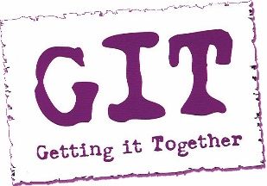
Contact: Ayla Garlick 0448559968

From Harm to Calm
EMOTION REGULATION + SOCIAL SKILLS
Support group for parents of teenage girls

Do you have a teenage daughter with problems regulating her emotions and behaviours? Self-harm, drug abuse and other high-risk behaviours in teenagers represent huge challenges to families. If you are the parent of a teen with intense emotions who lashes out or engages in troubling behaviour, you may be unsure of how to respond in a compassionate, constructive way.
Using Dialectical Behavioural Therapy, this group will give you the tools needed to help your teenage daughter regulate her emotions. In addition, you'll learn the skills for managing your own reactions so you can survive these difficult years and help your teen thrive.
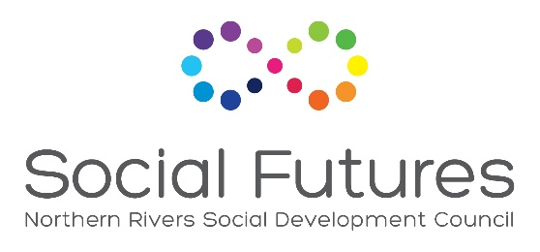
Thursdays 6:30 – 8:30pm
16th – 21st Nov
Ocean Shores

Contact: Ayla Garlick 0448559968

