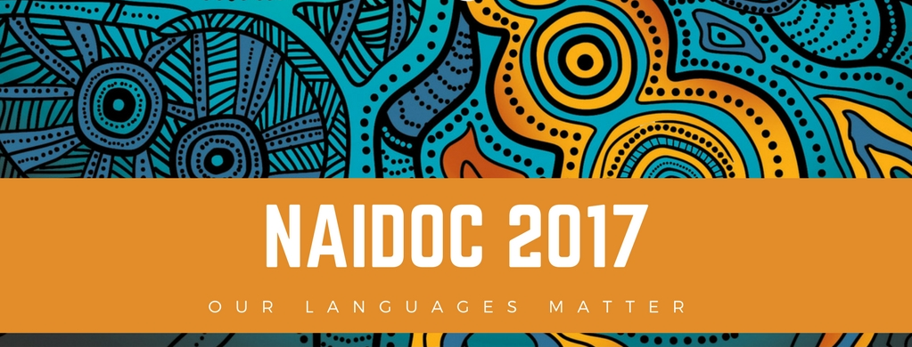  10th July 2017  at the YWCA Goonellabah  NAIDOC Week highlights the rich & diverse culture of Aboriginal & Torres Strait Islander peoples- the First Australians.  This year’s theme – Our Languages Matter – aims to emphasise & celebrate the unique and essential role that Indigenous languages play in cultural identity.  - Hip Hop Workshop with TLK.  - Solid Mob Workshop – Healthy Bodies, Healthy Minds.  - Arts & Crafts Workshops.  - BBQ Lunch & Afternoon Tea.  Transport to & from event will be available so please let us know if your require transport.  We acknowledge the Traditional Owners of the land where we live & work & their continuing connection to land, water, sea & community. We pay our respects to Australias First Peoples; to their unique & diverse cultures, and to Elders past, present & future. | Young NAIDOC Celebrations  ────  Healthy Bodies, Healthy Minds.  ────  TLK  SOLID MOB  BUNDJALUNG BUNARMS  ────  9:45am – 4:30pm  ────  Social futures  Keen Street, Lismore  NSW 2480  Contact Person:  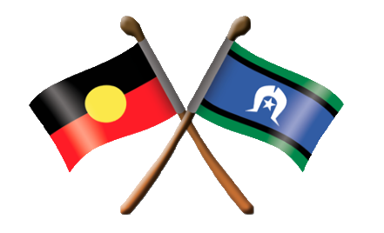  Mischarna Gordon 0439449477

