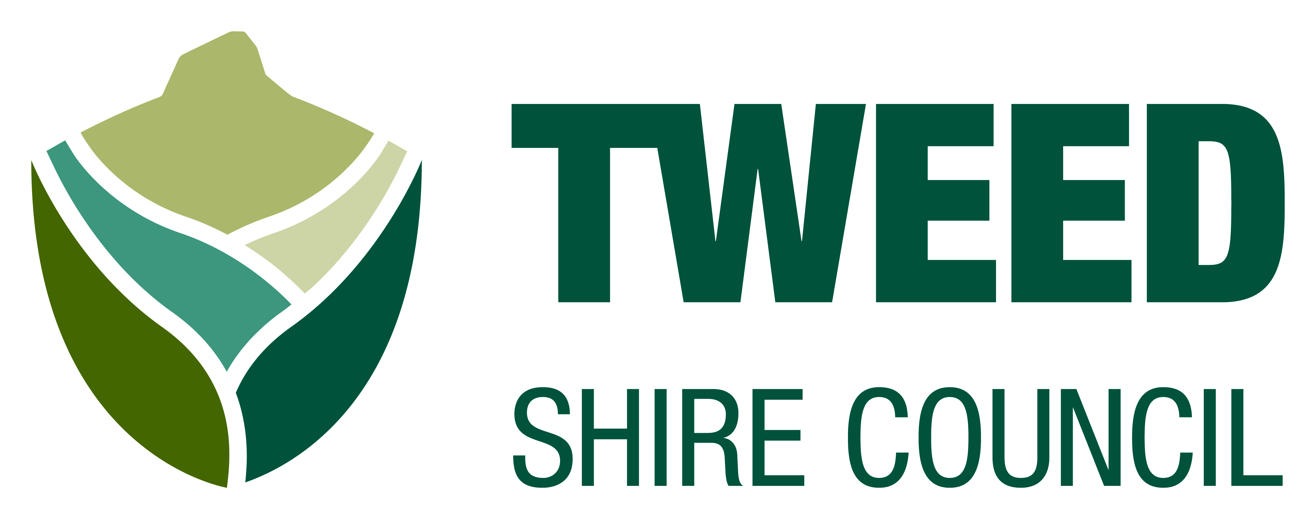
Access and Inclusion Awards 2017

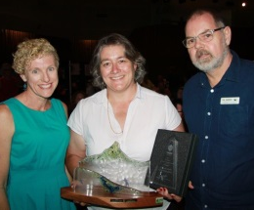
For International Day of People with Disability
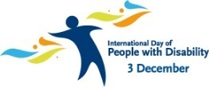

Why we hold these awards

We want a community that accepts and welcomes everyone.
These awards tell the community what is important for people with disability. They reward people who are doing a good job for access and inclusion.

Access means you can go where you need to in the community. This includes into building, on transport, in parks and to events. It means there are toilets you can use.

Inclusion means you feel part of the community and you get fair service.

Use this form to tell us who is doing a good job.

There are 4 parts to this form

Part 1 – Is about you (The nominator)

Part 2 – Is about who is doing a good job (Your nominee)

Part 3 – What they do for access and inclusion

Part 4 – How to send in your form

Part 1 – About you (The nominator)

Your name ___________________________________

Your phone number ____________________________

Your email ___________________________________

Part 2 – Who is doing a good job for access and inclusion (Your nominee)

Name _______________________________________

Phone number ________________________________

Email ________________________________________

Address _____________________________________

Has your nominee has agreed to be nominated for the awards _______

Part 3 – What do they for access and inclusion
Put a tick in the box for yes

For access

Do they have

A car park for people with disability

A flat path to the door

A wheelchair toilet

A low counter

Staff who help

What else do they do for good access?

Put a tick in the box for yes

For inclusion

Do they help people

Get fair service

Get a job

With art, music or crafts

With sport or leisure activities

With shopping

At school

At TAFE

At work

What else do they do the help people feel part of the community?

Put a tick in the box for yes

For inclusion

Who they help with a disability

Women

Men

Children

Carers

Aboriginal people

People from other countries

Older people

Tell us more about who they help

Part 4 – How to send in your form

By Mail:
Tweed Shire Council
Attention: Karen Collins
PO Box 816 Murwillumbah
NSW 2484

By email to Karen Collins
kcollins@tweed.nsw.gov.au

By phone – contact Karen Collins
02 66702442

Do the online form on our website
www.tsc.tweed.nsw.gov.au
Hot Topics
2017 Access and Inclusion Awards

Send your form by
Friday 29 September

This is a large print Plain English version of Tweed Shire Council 2017 Access and Inclusion Awards nomination form launched on 22 May 2017. The original document can be found at www.tsc.tweed.nsw.gov.au under Hot Topics

