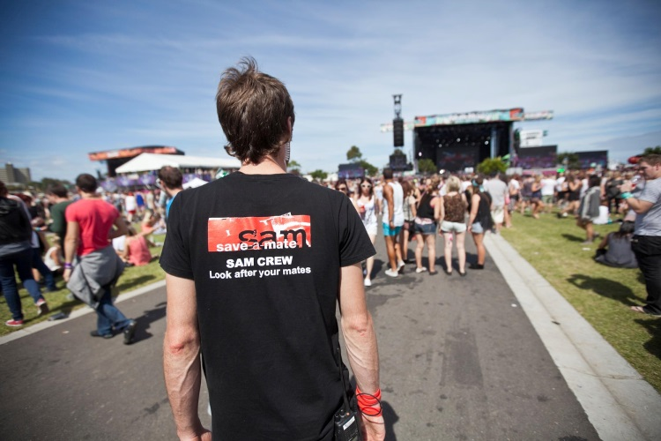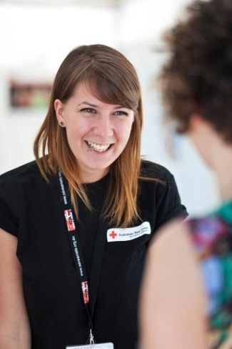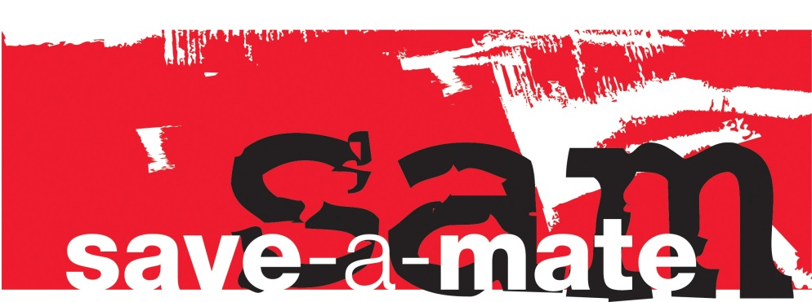

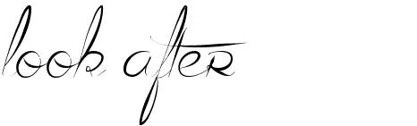

**save-a-mate Alcohol and Other Workshop**

The Australian Red Cross save-a-mate (SAM) program aims to provide participants with the skills and knowledge to prevent, recognise and respond to emergencies that may result from alcohol and other drug use.

Although there is no absolute safe way to use drugs, and despite the potential associated harms some people will still choose to use drugs. This course provides accurate and non-judgemental education allowing participants to make informed decisions about drug use and support others to do the same.

On successful completion of a SAM course participants will be awarded a certificate of attendance.

**What does the course cover?**

* Drugs and their classifications
* Drugs and the central nervous system
* Risk factors for overdose
* Signs and symptoms of an overdose
* Responding to an overdose
* Harm reduction strategies

**Course Information**

The SAM program has been running in Australia for nearly 20 years, educating approximately 10,000 young people each year. In 2013, SAM received a Highly Commended Award for Excellence in Service for Young People from the Alcohol and other Drugs Council of Australia.

The relevance of the SAM program lays in the fact that many alcohol and other drug emergencies (including overdoses) are actually witnessed by someone else. Prevention, recognition and early intervention responses can have a significant impact on the outcome for a person.

The training is an interactive workshop. Group sizes and duration of the workshops can be negotiated in the booking process.

For more information contact:

**save-a-mate** **Trainer**

**Sharyn Marshall**

Phone: 0498 002 534

Email:

[smarshall@redcross.org.au](mailto:smarshall@redcross.org.au)

**www.saveamate.org.au**