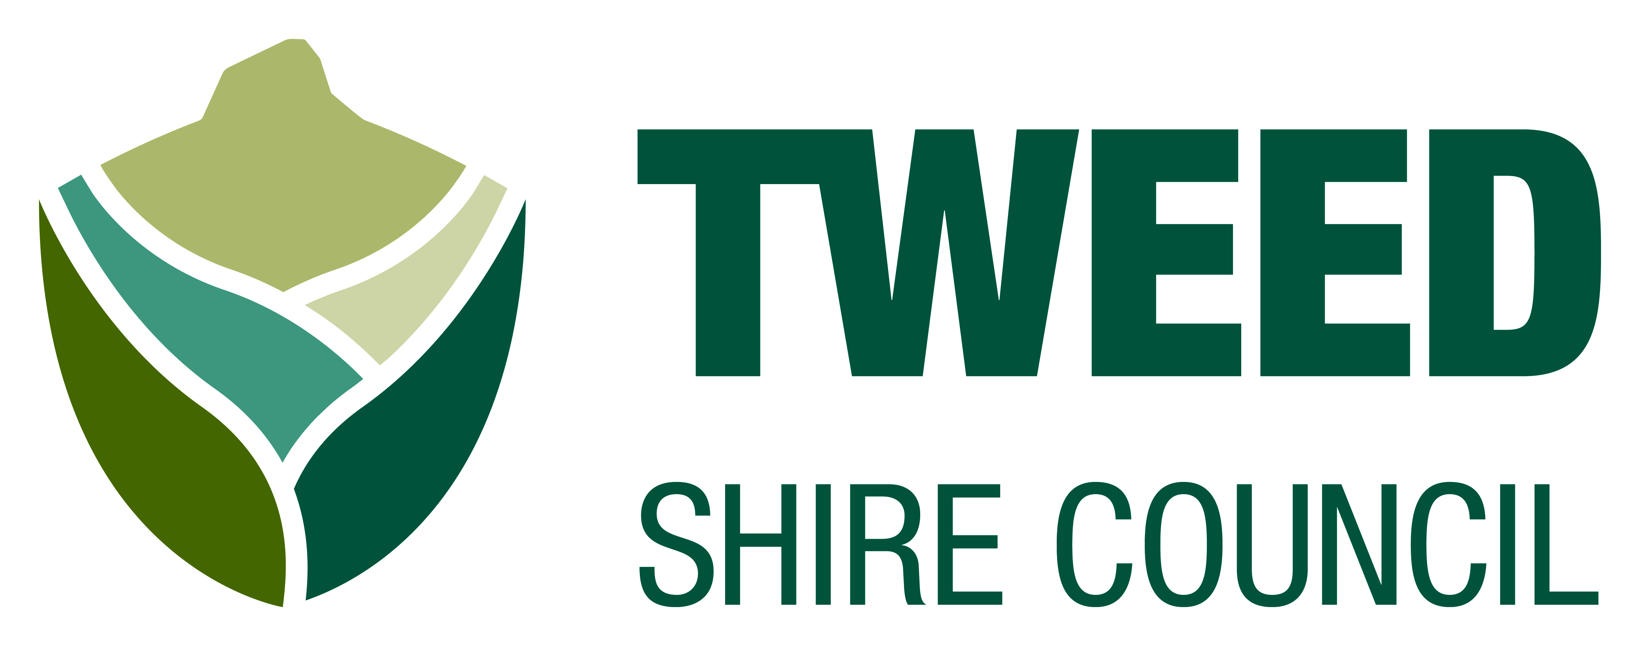
Access and Inclusion Awards 2017
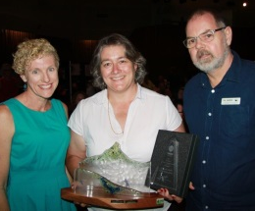

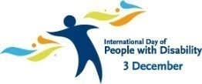
For International Day of People with Disability

These awards

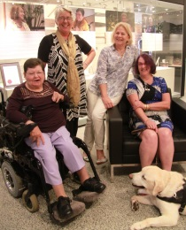
- tell the community what is important for
- people with disability

- are for people who do a good job.

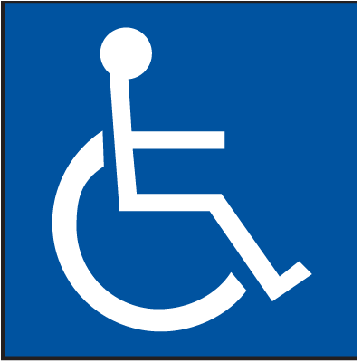
Access means

You or the person you help

- can go into buildings

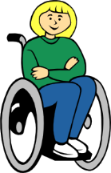
- can use the toilets.

Inclusion means

You or the person you help

- are part of the community

- get a fair service.

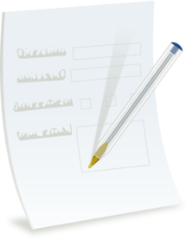

Use this form.
Tell us who is doing a good job.

There are 4 parts to this form

Part 1 – About you

Part 2 – About who is doing a good job

Part 3 – About what they do
for access and inclusion

Part 4 – About how to send your form

Part 1 – About you

Your name ____________________________________

Your phone number ____________________________

Your email ____________________________________

Part 2 – Who is doing a good job

Name ________________________________________

Phone number _________________________________

Email ________________________________________

Address ______________________________________

Part 3 – What they do
for access and inclusion
Put a tick in the box for yes

Do they have

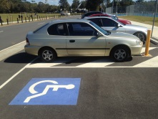
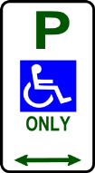
- a car park

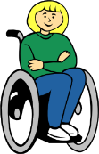
- a flat path to the door

- a wheelchair toilet

Put a tick in the box for yes

Do they have

- a low counter

- staff who help.

Put a tick in the box for yes

Do they help people get

- fair service

- a job.

Put a tick in the box for yes

Do they help people do

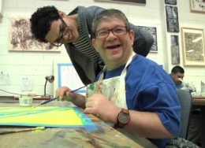
- art

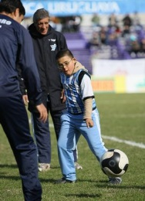
- sport

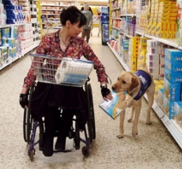
- shopping.

Put a tick in the box for yes

Do they help people at

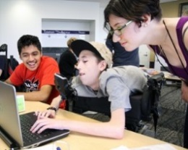
- school

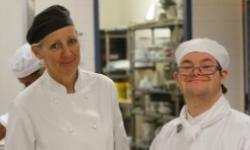
- TAFE

- work.

Put a tick in the box for yes

Who they help with a disability

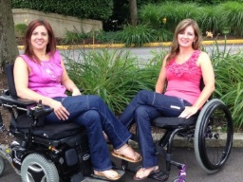
- women

- men

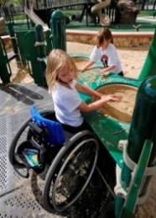
- children

Put a tick in the box for yes

Who they help with a disability

- carers

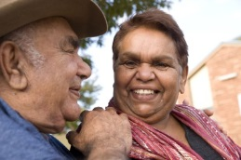
- aboriginal people

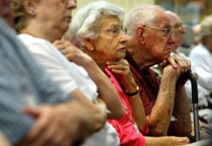
- old people.

Part 4 – How to send in your form

Mail
Tweed Shire Council
PO Box 816 Murwillumbah
NSW 2484

Email Karen
kcoillins@tweed.nsw.gov.au

Phone Karen
02 66702442

Do the online form on our website
www.tsc.tweed.nsw.gov.au
Hot Topics
2017 Access and Inclusion Awards

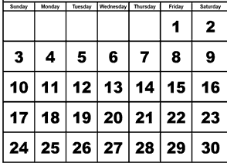
Send your form by
September
Friday 29 September 2017

This is an Easy English version of Tweed Shire Council 2017 Access and Inclusion Awards nomination form. The form was launched on 22 May 2017. The original document can be found at www.tweed.nsw.gov.au under Hot Topics

